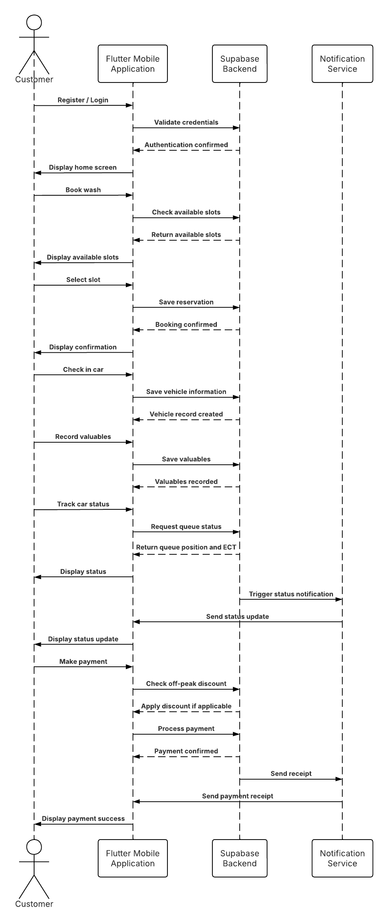
The Sequence Diagram illustrates the dynamic interactions between the Customer, Staff, and the system components of the Lifestyle Square Car Wash Management System. It shows the chronological flow of messages exchanged between actors and objects to complete the main use cases: Registration/Login, Request Service, Join Queue, Manage Queue, Update Status, and Make a Payment.

The diagram focuses on the time-ordered sequence of events that occur when a customer requests a car wash service and staff manage the vehicle through the operational workflow.

Step-by-Step Description of Interactions

- Customer → Flutter App: Customer registers or logs in, Supabase validates the details, and the home screen is displayed.
- Customer → Flutter App → Supabase: Customer books a wash, Supabase returns available slots, which are displayed.
- Customer → Flutter App → Supabase: Customer selects a slot, Supabase saves the reservation and confirms the booking.
- Customer → Flutter App → Supabase: Customer checks in the car, Supabase saves the vehicle information and confirms the record.
- Customer → Flutter App → Supabase: Customer records valuables, Supabase saves and confirms the record.
- Customer → Flutter App → Supabase: Customer tracks car status, Supabase returns the queue position and ECT, which are displayed.
- Supabase → Notification Service → Flutter App → Customer: A status update is sent to the Flutter App and then displayed to the customer.
- Customer → Flutter App → Supabase: Customer makes a payment. Supabase checks for an off-peak discount, processes the payment, and confirms it.
- Supabase → Notification Service → Flutter App → Customer: A payment receipt is sent to the Flutter App and then displayed to the customer.

The Link

https://lucid.app/lucidchart/f7ce1a46-9fe2-4f04-aa4c-5b53fe18f644/view

Asp.net web and Staff sequence diagram
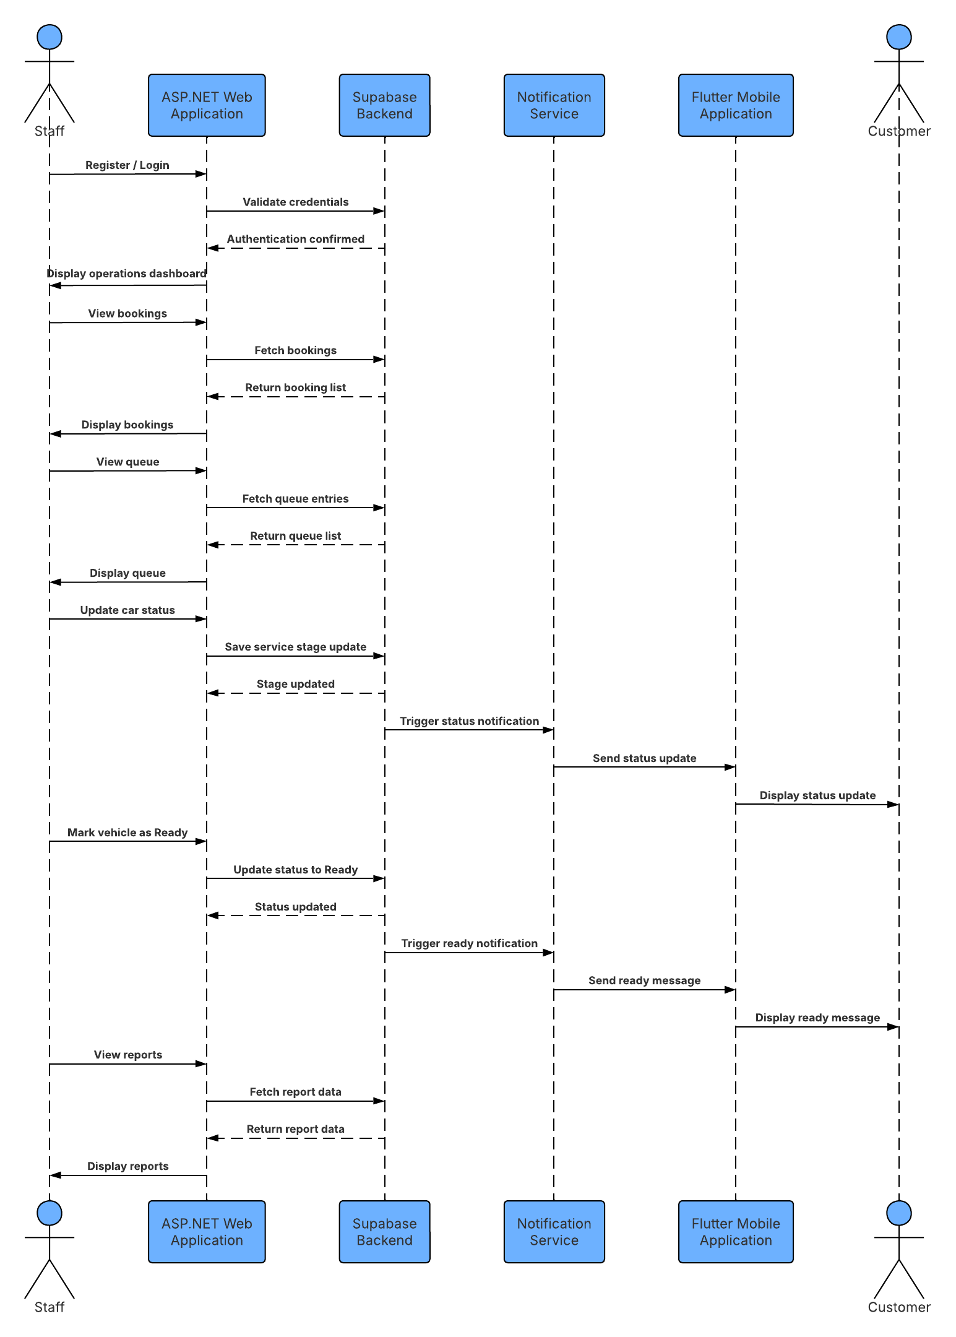
Step-by-Step Description of Interactions

- Staff → ASP.NET Web : Staff enters login credentials, which are validated by Supabase, and the operations dashboard is displayed.
- Staff → ASP.NET Web → Supabase: Staff views bookings, Supabase returns the booking list, which is displayed.
- Staff → ASP.NET Web → Supabase: Staff views the queue, Supabase returns the queue list, which is displayed.
- Staff → ASP.NET Web → Supabase: Staff updates the car's service stage, Supabase saves the update.
- Supabase → Notification Service → Flutter App → Customer: A status notification is sent to the Flutter App and then displayed to the Customer.
- Staff → ASP.NET Web App → Supabase: Staff marks the car as Ready, Supabase updates the status.
- Supabase → Notification Service → Flutter App → Customer: A "Ready for collection" message is sent to the Flutter App and then displayed to the Customer.
- Staff → ASP.NET Web App → Supabase: Staff views reports, Supabase returns the report data, which is displayed.

The Link
https://lucid.app/lucidchart/0828ef9f-e7e0-48d9-9d49-ea0897844e4f/view

